Project 01

Problem Statement:
You are tasked with setting up a CI/CD pipeline using Jenkins to streamline the deployment process of a simple Java application. The pipeline should accomplish the following tasks:
- Fetch the Dockerfile: The pipeline should clone a GitHub repository containing the source code of the Java application and a Dockerfile.
- Create a Docker Image: The pipeline should build a Docker image from the fetched Dockerfile.
- Push the Docker Image: The pipeline should push the created Docker image to a specified DockerHub repository.
- Deploy the Container: The pipeline should deploy a container using the pushed Docker image.

Deliverables:
- GitHub Repository: A GitHub repository containing:
  - The source code of a simple Java application.

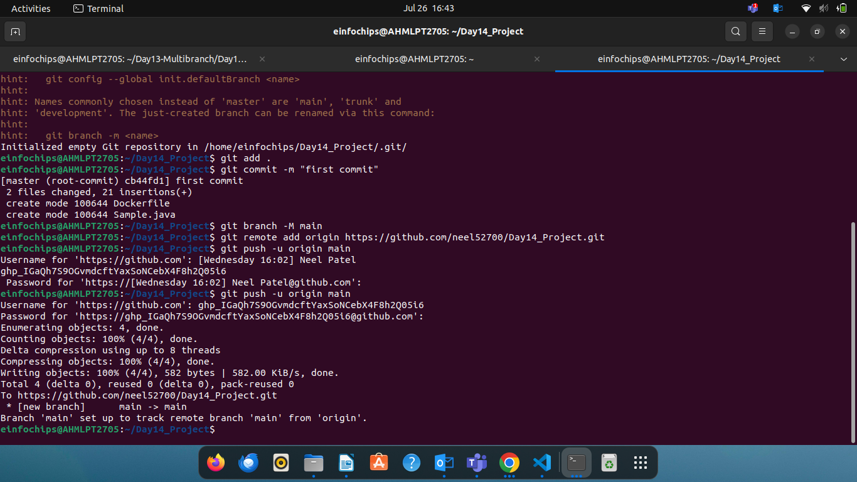

  - A Dockerfile for building the Docker image.

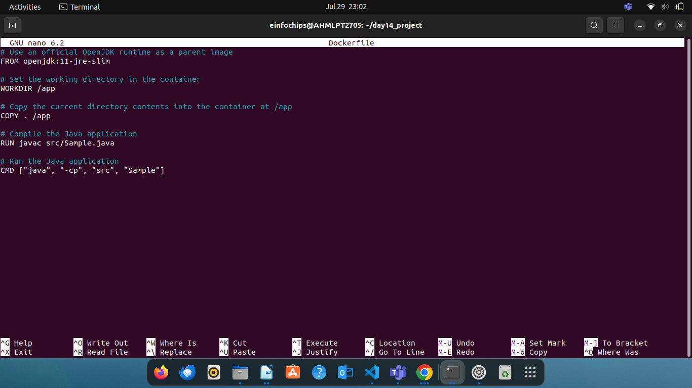

- Jenkins Pipeline Script: A Jenkinsfile (pipeline script) that:
  - Clones the GitHub repository.
  - Builds the Docker image.
  - Pushes the Docker image to DockerHub.
  - Deploys a container using the pushed image.

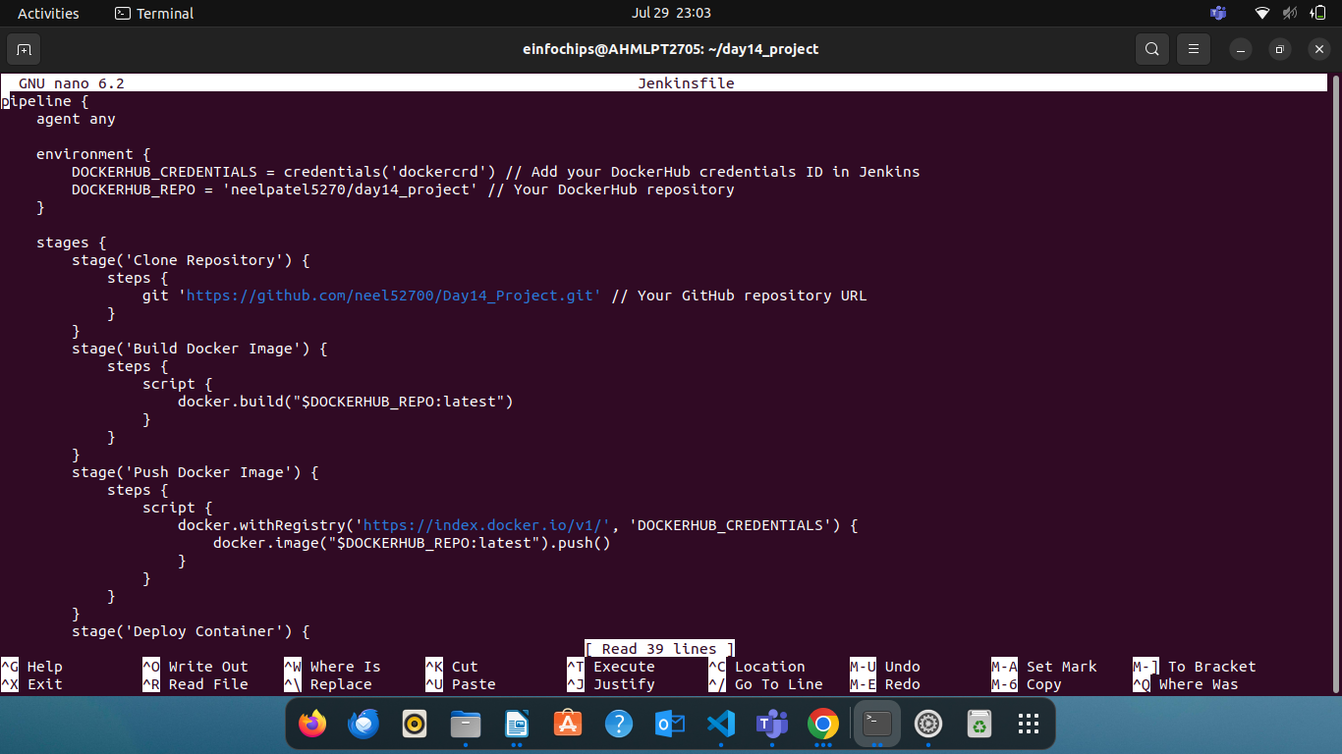

- DockerHub Repository: A DockerHub repository where the Docker images will be stored.

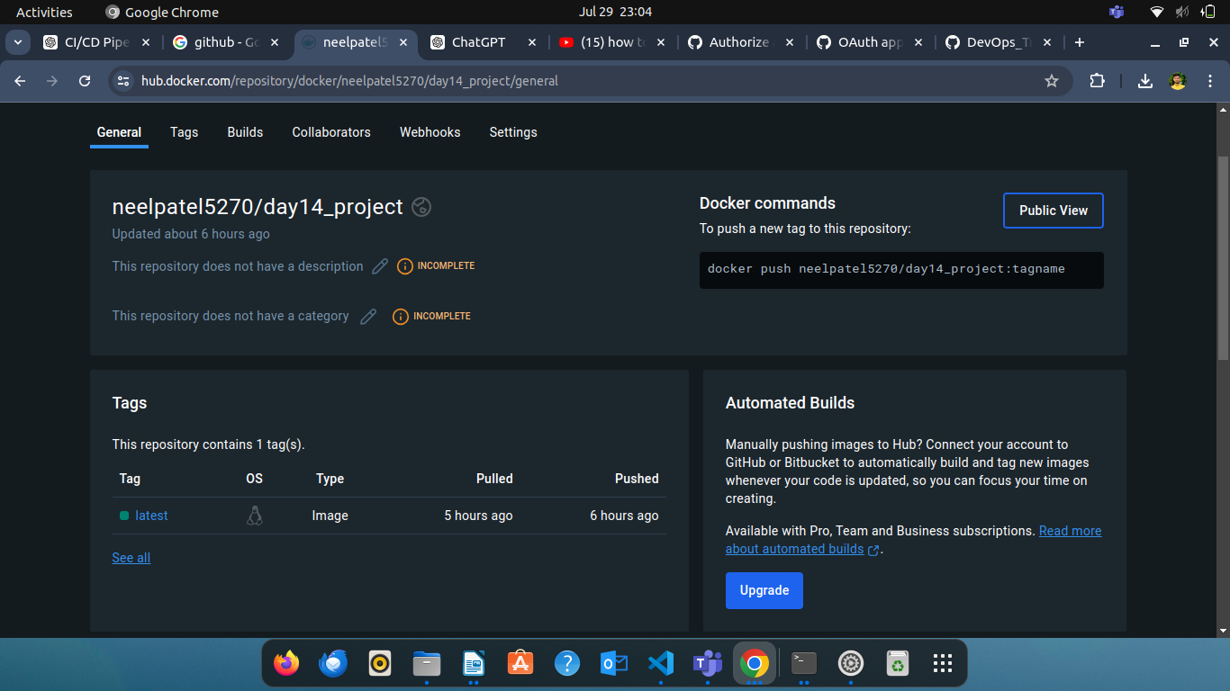

- Jenkins Setup:
  - Jenkins installed and configured on a local Ubuntu machine.
  - Required plugins installed (e.g., Git, Docker, Pipeline).

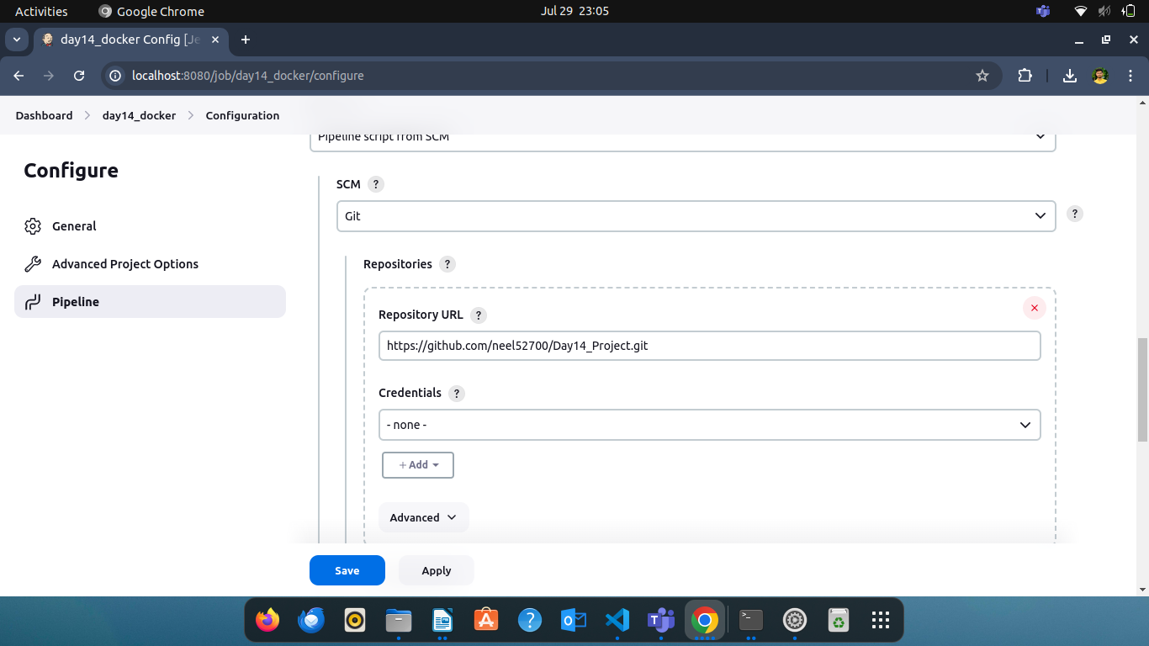

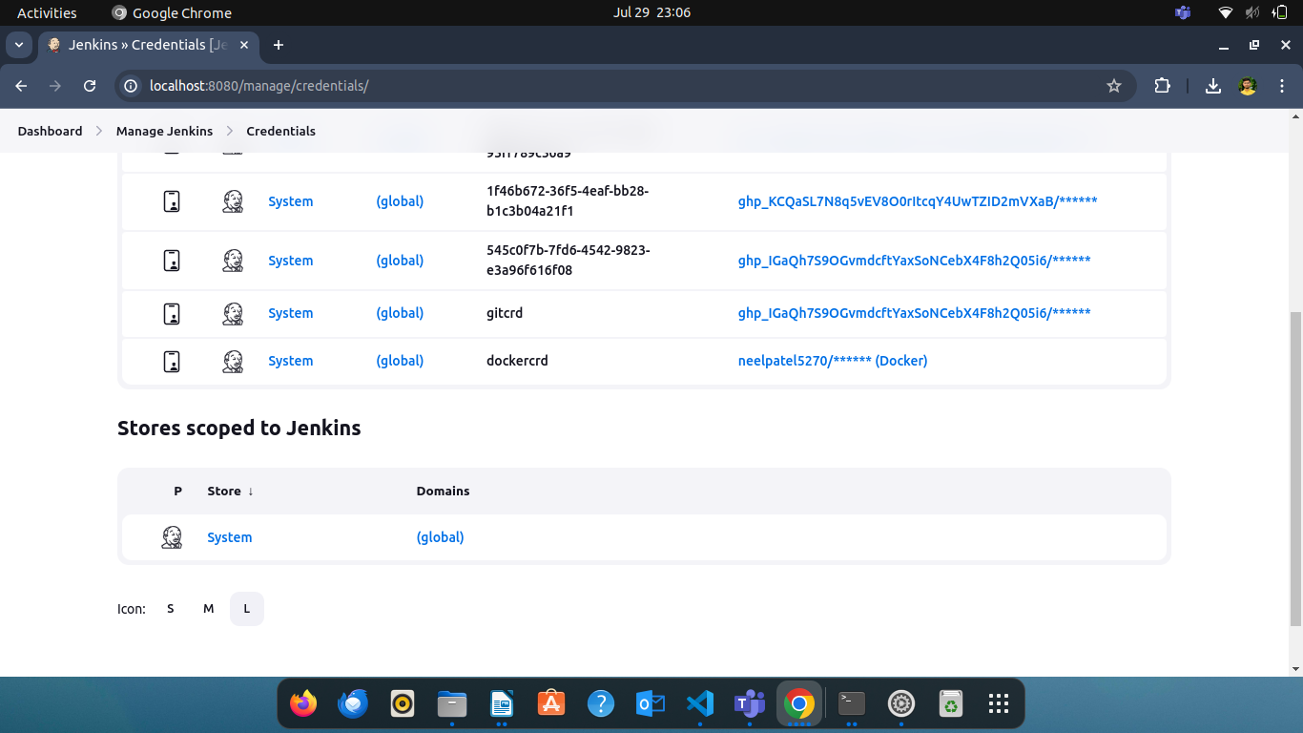
- Documentation: Detailed documentation explaining:
  - How to set up the local Jenkins environment.
  - Configuration steps for the pipeline.
  - Instructions for verifying the deployment.
